Results of Exercise 4

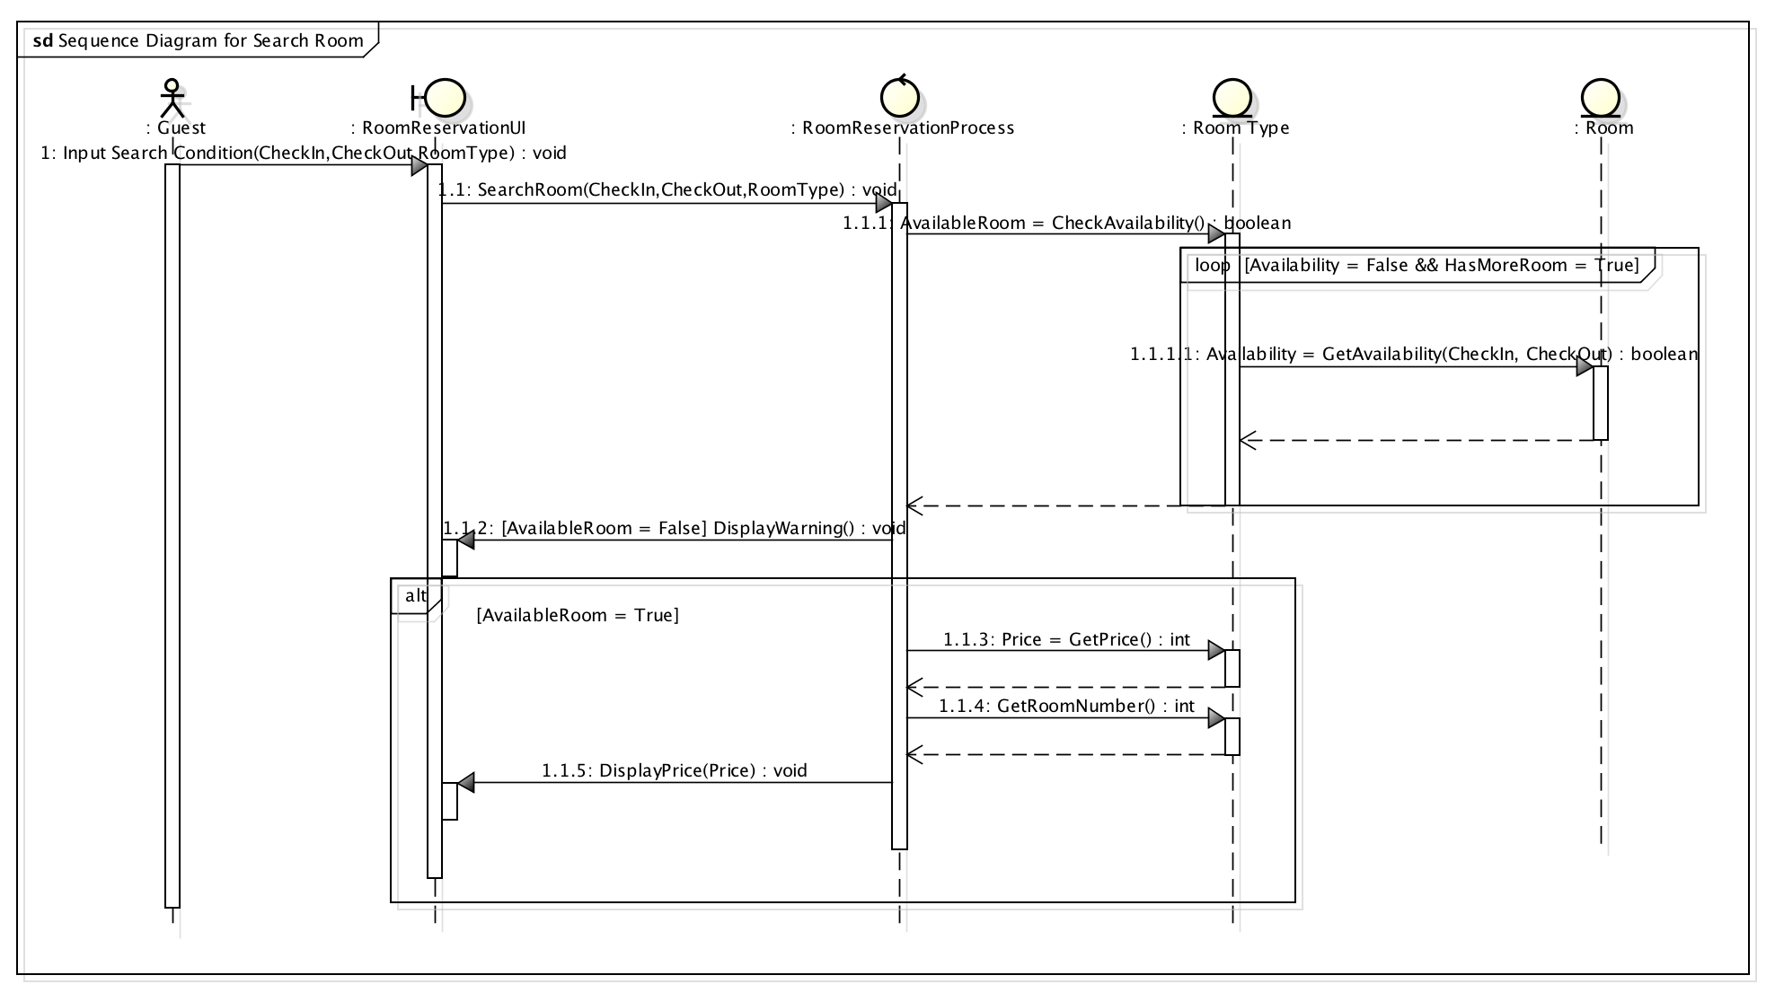
Based on the Communication diagram made from the previous exercise, we can develop a sequence diagram. In total, 6 diagrams were made; 1 Class diagram on design level, and 5 sequence diagrams. Since these sequence diagram will describe the same process as in exercise 3, only the important feature will be discussed.

- Sequence Diagram for Search Room

It can be seen that this process will require a loop in order to search for available room in a given time period. If the loop breaks because there is no more room, the system will warn that there is no available room.

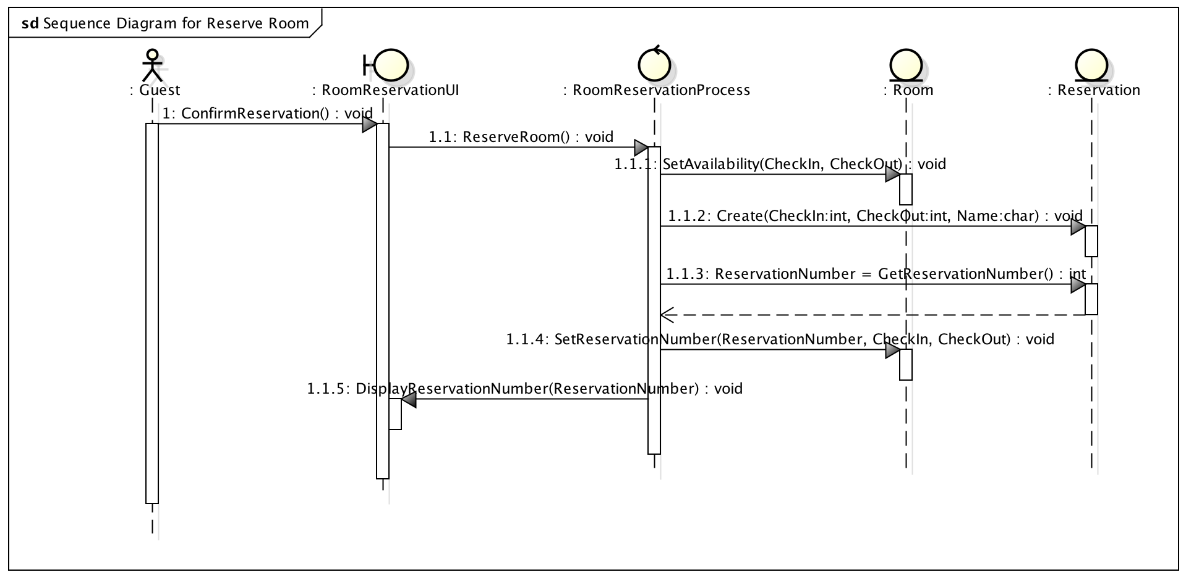
- Sequence Diagram for Reserve Room.

This is exactly the same as the process lined out in previous exercise. It can be seen that the constructor for reservation will need three inputs, CheckIn date, CheckOut date, and the Guest’s name. The number should be procedurally generated for increased security.

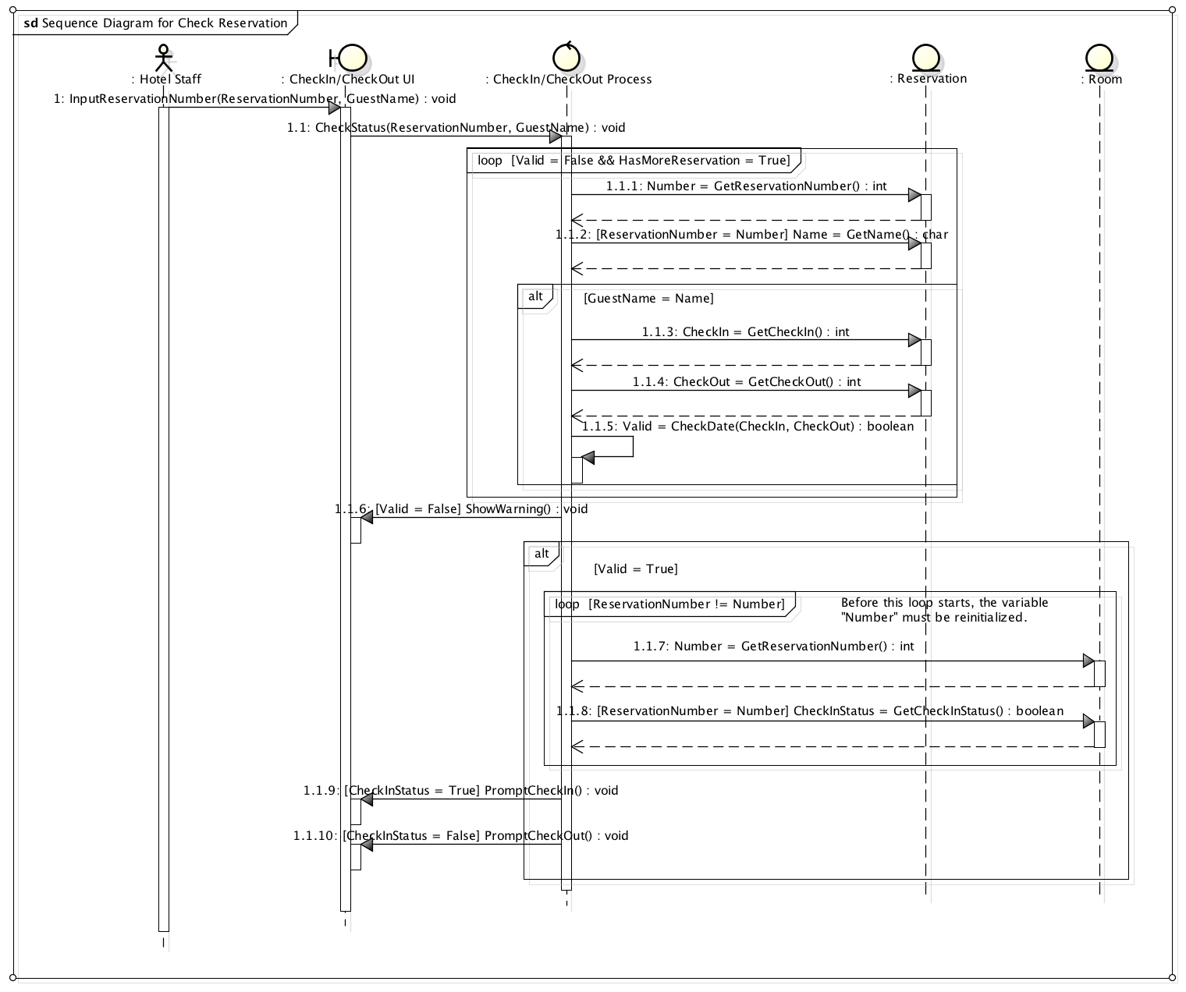

- Sequence Diagram for Check Reservation (Previous page)

Also the most complex Sequence Diagram. It is much more easily understood than the previous communication diagram, however.
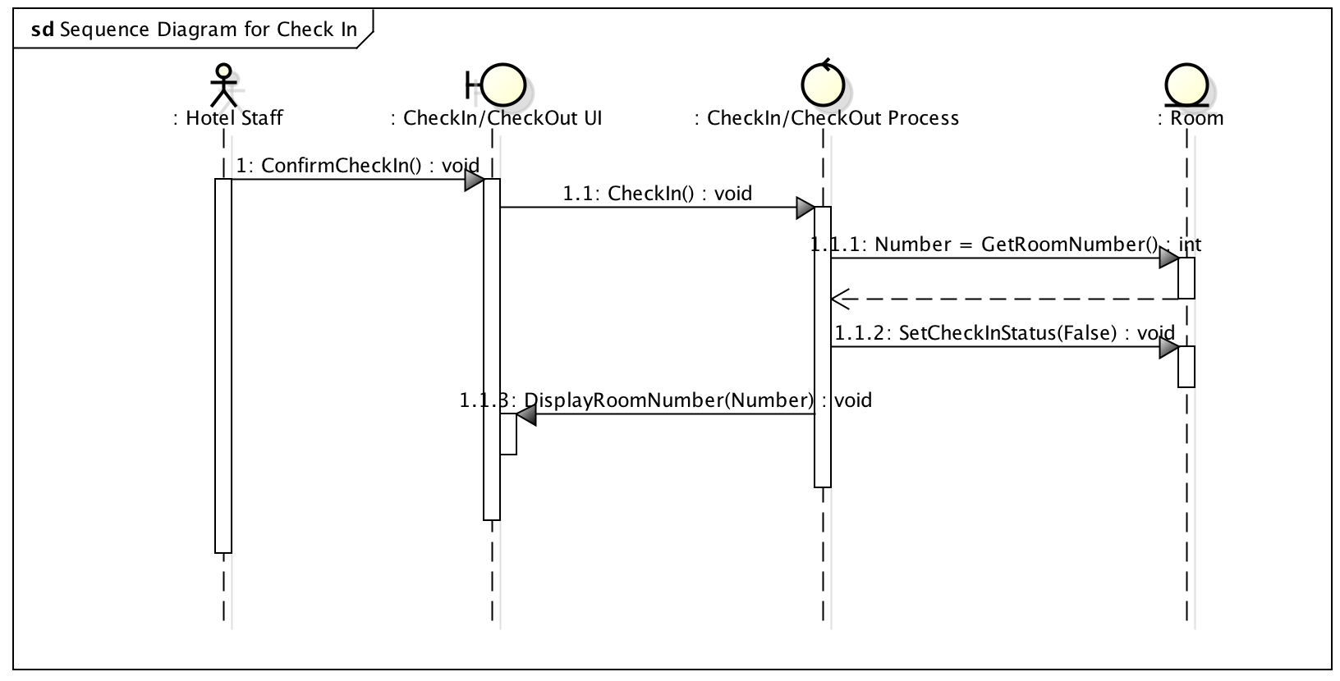
- Sequence Diagram for Check In.
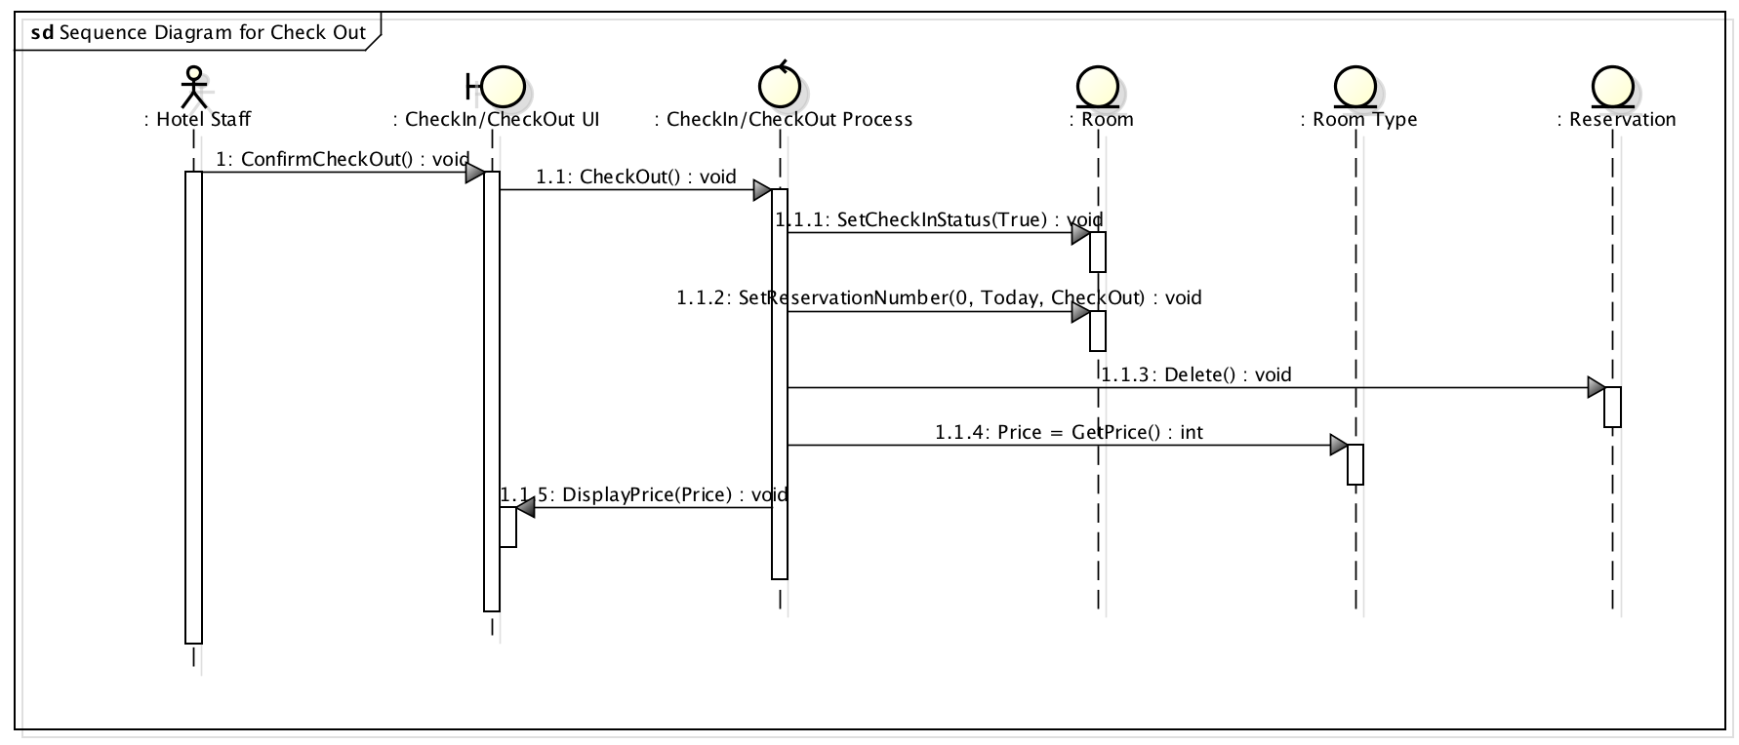

- Sequence Diagram for Check Out.

It should be noted that, in step 1.1.2, the reason that the inputted argument is (0, Today, Checkout) is so that the function will clear out the reservation of the room, in case the guest check out early.

